Project Planning Phase
Project Planning Template (Product Backlog, Sprint Planning, Stories, Story Points)
Date | 07 September 2026
Team ID
Project Name | Automated Network Request Management in ServiceNow
Maximum Marks | 5 Marks

Product Backlog, Sprint Schedule, and Estimation (4 Marks)
Use the following product backlog and sprint schedule for the proposed solution.
Sprint | Functional Requirement (Epic) | User Story Number | User Story / Task | Story Points | Priority | Team Members
Sprint-1 | Network Request Submission | USN-1 | As a requester, I can submit a network request through the Service Catalog. | 3 | High
Sprint-1 | Network Request Submission | USN-2 | As a requester, I can select a request type, access level, device, environment, and priority. | 3 | High
Sprint-1 | Dynamic Form & Validation | USN-3 | As a requester, I can see fields relevant to the selected request type. | 3 | High
Sprint-1 | Dynamic Form & Validation | USN-4 | As a requester, my requester information can be auto-populated from my user record. | 2 | Medium
Sprint-1 | Dynamic Form & Validation | USN-5 | As a requester, I can enter valid firewall IP addresses and port numbers. | 3 | High
Sprint-2 | Approval & Fulfillment | USN-6 | As a manager, I can review and approve a submitted network request. | 3 | High
Sprint-2 | Approval & Fulfillment | USN-7 | As a manager, I can reject a network request when it is not appropriate. | 2 | High
Sprint-2 | Approval & Fulfillment | USN-8 | As a Network Team member, I can receive a fulfillment task after approval. | 3 | High
Sprint-2 | Request Tracking | USN-9 | As a requester, I can see the current state of my network request. | 2 | High
Sprint-3 | Notifications & Monitoring | USN-10 | As a requester, I can receive notifications for important request events. | 2 | Medium
Sprint-3 | Notifications & Monitoring | USN-11 | As a Network Team member, I can monitor requests using reports. | 2 | Medium
Sprint-3 | Notifications & Monitoring | USN-12 | As a manager, I can monitor pending requests and approvals using the dashboard. | 3 | Medium
Sprint-4 | Security & Access Control | USN-13 | As an administrator, I can manage roles and groups for requesters, approvers, and fulfillers. | 2 | Medium
Sprint-4 | Testing & Deployment | USN-14 | As an administrator, I can test the complete request, approval, rejection, fulfillment, and deployment process. | 3 | High

Project Tracker, Velocity & Burndown Chart (4 Marks)
Sprint | Total Story Points | Duration | Sprint Start Date | Sprint End Date (Planned) | Story Points Completed (as on Planned End Date) | Sprint Release Date (Actual)
Sprint-1 | 14 | 6 Days | 24 Aug 2026 | 29 Aug 2026 | 14 | 29 Aug 2026
Sprint-2 | 10 | 6 Days | 31 Aug 2026 | 05 Sep 2026 | 10 | 05 Sep 2026
Sprint-3 | 7 | 6 Days | 07 Sep 2026 | 12 Sep 2026
Sprint-4 | 5 | 6 Days | 14 Sep 2026 | 19 Sep 2026

Velocity:
The planned backlog contains 36 story points across four sprints. Using a 6-day sprint duration and an average planned capacity of approximately 1.50 story points per project day, the sprint plan is divided according to the backlog above. Velocity can be recalculated after each sprint using completed story points.
Burndown Chart:
A burndown chart is a graphical representation of work left to do versus time. The chart below compares planned remaining story points with an illustrative actual progress line for project tracking.
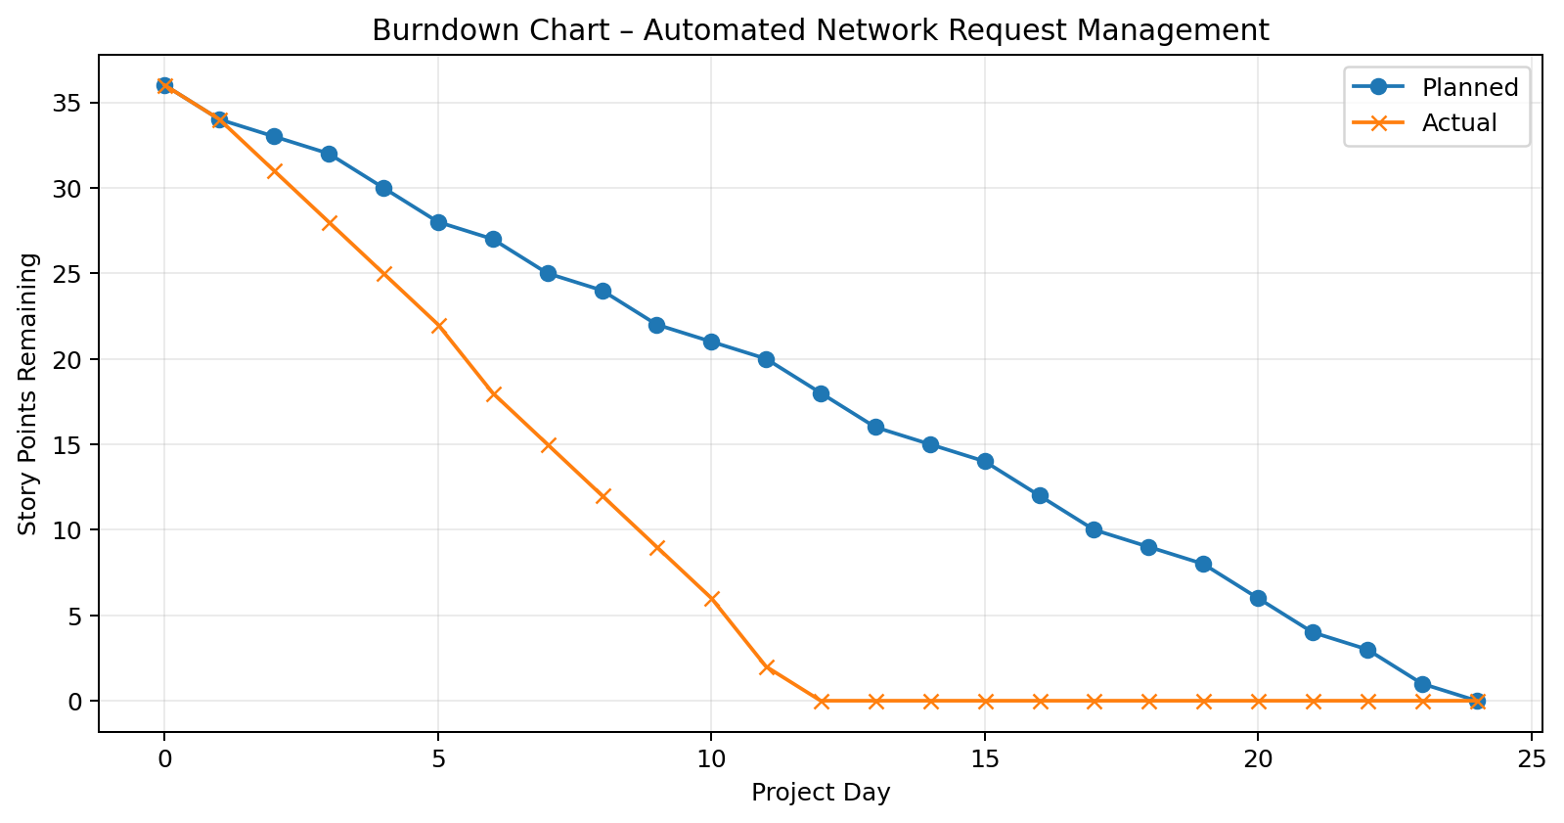

Planning Note: Team Members and future sprint completion/release fields are left blank where the actual team assignment or completion date was not provided. The backlog, story points, and sprint allocation are based on the implemented Network Request solution.

